Lab 2 Report

Willow Westbrook
Loyola Marymount University
BSAN-6070-02: Intro to Machine Learning

Contact Me:
wwestbro@lion.lmu.edu

Introduction
Lab 2 picks up right where Lab 1 left off, diving deeper into understanding what makes a product popular based on its attributes and customer feedback. In Lab 1, I used Ordinary Least Squares (OLS) regression to explore the key drivers behind product ratings. While that gave me a solid starting point, it also revealed some issues like multicollinearity and heteroscedasticity that needed to be addressed. So, in Lab 2, I focused on refining the model by introducing regularization techniques, Ridge, Lasso, and Elastic Net, and running more thorough diagnostic tests to strengthen the analysis. The central question still stands: "What makes a product more popular based on its attributes and overall customer feedback?" But this time, I’m looking at it through a more rigorous lens, aiming to build a model that’s not only accurate but also robust and interpretable.
I worked with the same aggregated product monthly panel dataset, which includes detailed customer review data, things like ratings, recommendations, helpfulness scores, product prices, brand names, and customer demographics (skin tone, eye color, skin type, and hair color). The improvements made in Lab 2 have taken the project a step forward, giving me clearer insights into the factors that really drive product popularity.

Descriptive Analytics
The Distribution of Product Ratings (Graph 1) shows a similar pattern to what I saw in Lab 1—a right-skewed distribution with most ratings clustering around 4.0 and peaking at 5.0. This tells me that customers generally rate products favorably, but there’s still a noticeable spike at 1.0, showing some clear dissatisfaction in certain cases.
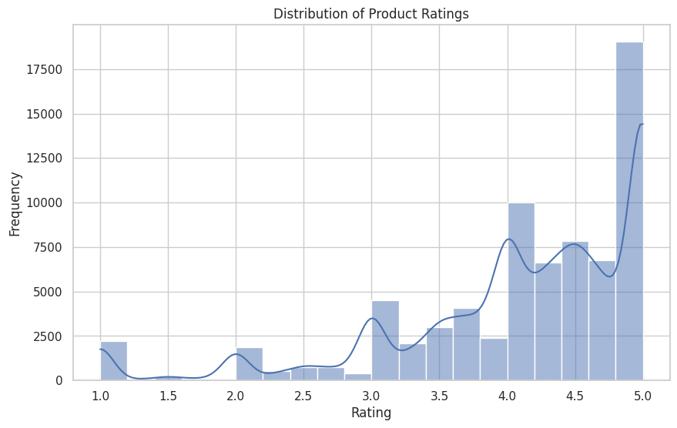
The skewed distribution raises some concerns for the regression model, especially regarding the normality assumption, which is something I dive deeper into later in the diagnostics.

Price vs. Rating Scatterplot
The Price vs. Rating Scatterplot (Graph 2) paints an interesting picture. Product prices are all over the place—most are under $500, but there are a few outliers that reach nearly $1,800. Despite this wide range, ratings mostly sit between 3.0 and 5.0, which suggests that price alone doesn’t really dictate how customers feel about a product.
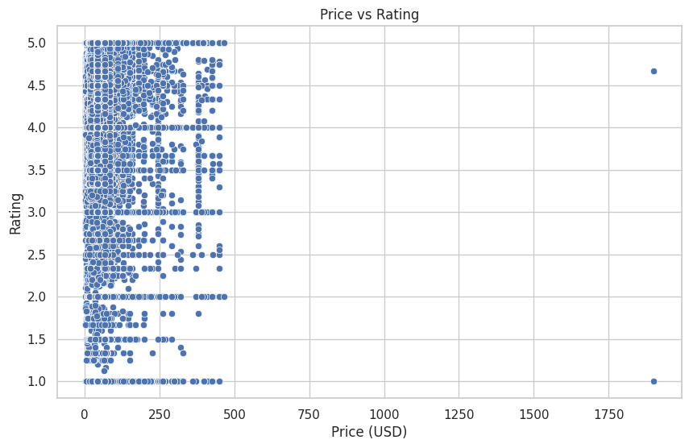
What stands out is how some high-priced products get stellar ratings while others totally flop. It’s a good reminder that price doesn’t guarantee quality in the eyes of consumers.
The Correlation Matrix (Graph 3) gives a deeper look at how the features in the dataset relate to each other. Most variables have weak correlations, but there are stronger associations among some of the one-hot encoded categorical variables, like brand names and demographics, which could lead to multicollinearity.
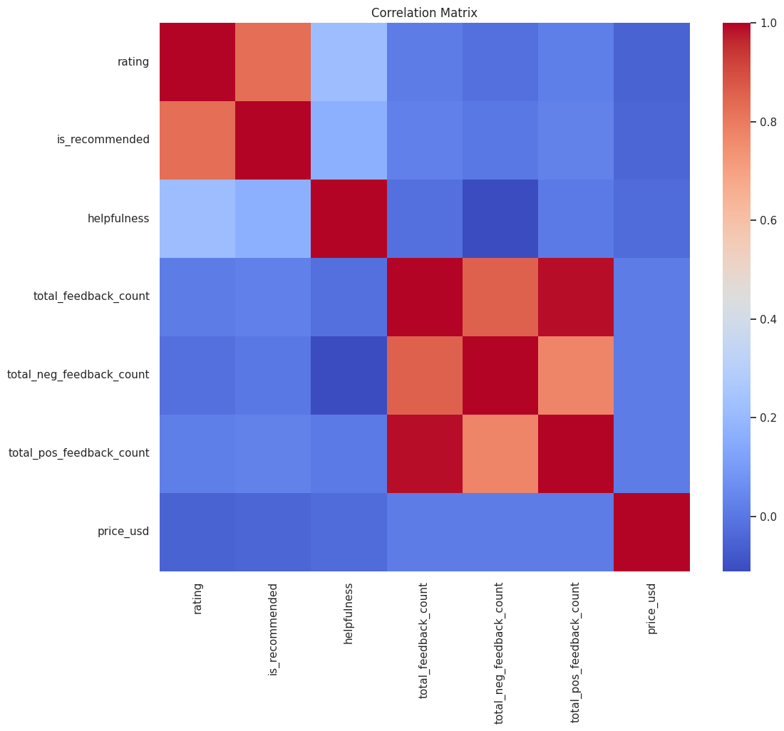
This is something I tackle later with regularization methods.

Regression Analysis
Starting with the Ordinary Least Squares (OLS) regression again, I got an R-squared value of 0.71, which means 71% of the variability in product ratings is explained by the model. That’s solid, but there were still some issues. Key takeaways from the OLS results:
- is_recommended had a strong positive correlation with product ratings, which makes sense—products that get recommended more often tend to be rated higher.
- helpfulness also had a positive impact, showing that helpful reviews correlate with higher ratings.
- price_usd had a slight negative effect on ratings, which aligns with the idea that customers might be more critical of pricier products.
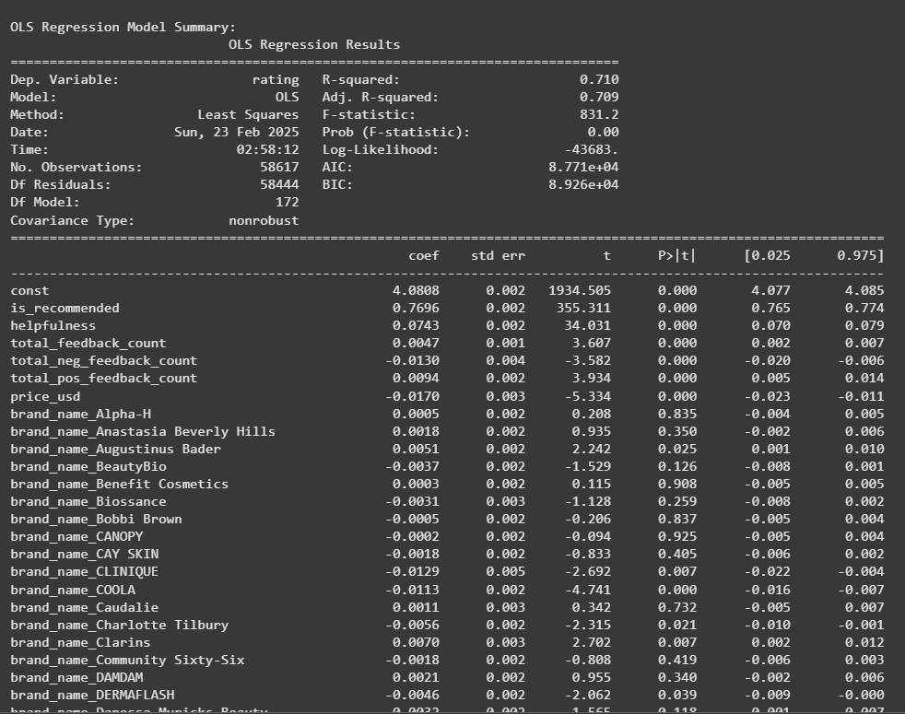
But the OLS model wasn’t perfect. There were clear signs of multicollinearity and heteroscedasticity, so I moved on to regularization techniques.
The Ridge Regression model helped address multicollinearity by shrinking the coefficients. After tuning with GridSearchCV, I found the optimal alpha value

that balanced bias and variance. Ridge was great for reducing overfitting but didn’t eliminate unnecessary features. Lasso Regression took things a step further by not only shrinking coefficients but also setting some to zero, effectively performing feature selection. The best alpha, 10.0, helped simplify the model without sacrificing too much accuracy.
Finally, I tried Elastic Net Regression, which combines Ridge and Lasso penalties. After tuning, I found the best alpha (0.1) and l1_ratio (0.1).

This model struck a good balance between handling multicollinearity and selecting key features.

Model Comparison
Here’s how the models performed based on R² and MSE:
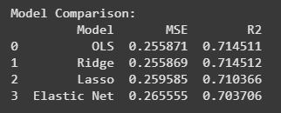
When comparing the models, both OLS and Ridge Regression performed similarly, with Ridge slightly edging out OLS with the lowest MSE (0.255869) and the highest R² (0.714512). Lasso had a marginally higher MSE, and Elastic Net, surprisingly, performed the worst among the four models with the highest MSE (0.265555) and the lowest R² (0.703706).
The bar charts below illustrate the MSE and R² comparisons across the models:
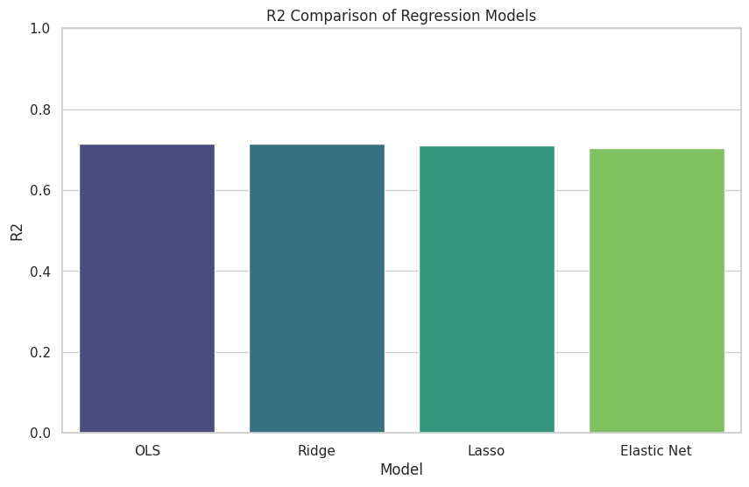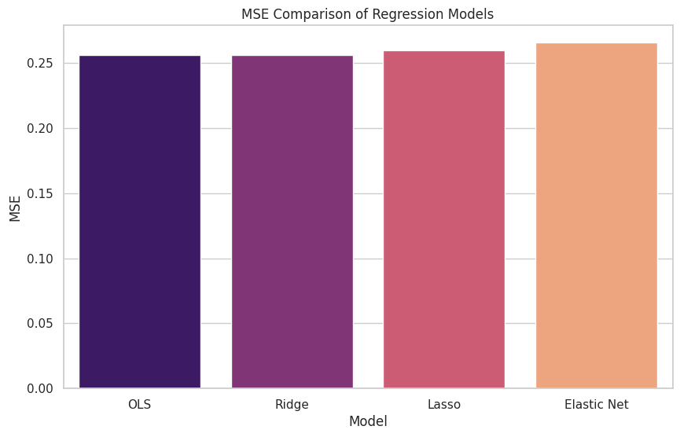

Contrary to initial expectations, Elastic Net didn't outperform the others, highlighting that in this case, simpler models like Ridge and even OLS were more reliable for predicting product ratings.

Diagnostic Tests Residual Analysis
The Residuals vs. Fitted Values plot for the Elastic Net model showed a mostly random scatter, but there were still signs of heteroscedasticity, something that’s tough to eliminate completely.
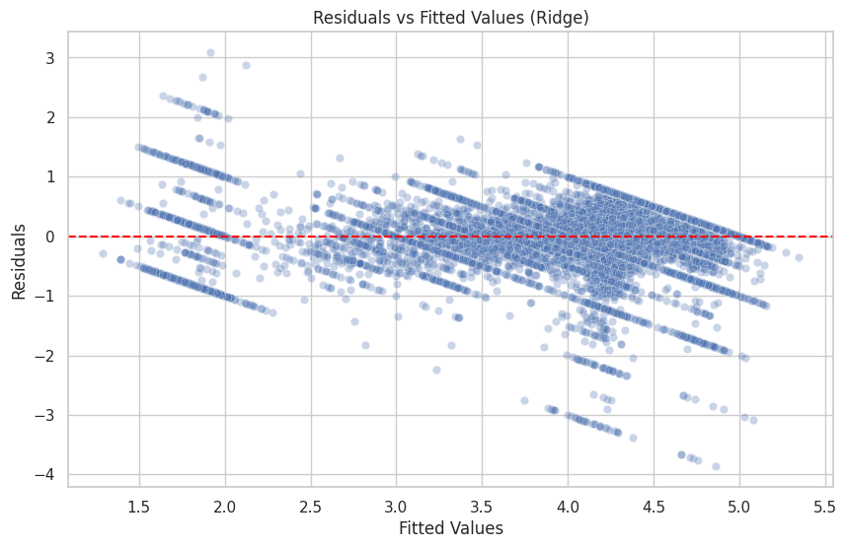

Durbin-Watson Test
The Durbin-Watson statistic was 1.806, which falls within the acceptable range (1.5 to 2.5), suggesting there wasn’t significant autocorrelation in the residuals.


Breusch-Pagan Test
The Breusch-Pagan test flagged heteroscedasticity with a p-value of 0.0, confirming what I saw in the residuals plot.
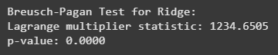

Q-Q Plot and Shapiro-Wilk Test
The Q-Q Plot revealed deviations from normality, especially at the tails, which was further confirmed by the Shapiro-Wilk test—the test returned a statistic of 0.903 and a p-value of 1.12e-48, indicating non-normal residuals.
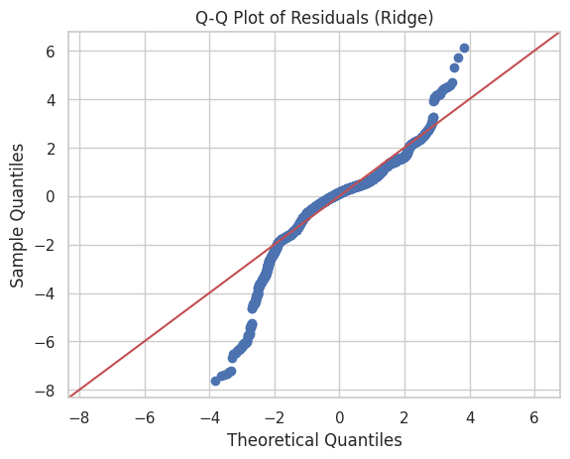

Variance Inflation Factor (VIF)
The VIF analysis really highlighted some major multicollinearity issues in the model. The features total_feedback_count, total_neg_feedback_count, and total_pos_feedback_count all had VIF values of infinity, which screams perfect multicollinearity. This likely means these variables are linearly dependent on each other, leading to instability in the model. The const term also had a sky-high VIF of 34.76, but that's expected since it’s the intercept.
Looking at the other variables:
- rating came in with a VIF of 3.36, showing some moderate correlation with other predictors.
- is_recommended wasn’t far behind with a VIF of 3.31, indicating similar levels of multicollinearity.
- helpfulness and price_usd were in the clear, with low VIFs (1.08 and 1.00, respectively), meaning they’re pretty independent from the rest.
This VIF output makes it clear that I need to tackle the multicollinearity, especially within the feedback count variables. I’ll likely need to consider feature engineering or even dimensionality reduction techniques to clean this up.

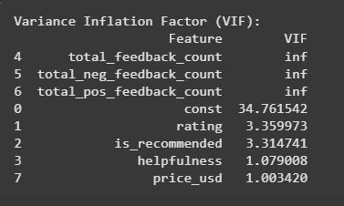
While Ridge and Lasso helped smooth out some of these issues, there’s still work to do. Future improvements should focus on restructuring the dataset to eliminate perfect multicollinearity and make the model more robust.

Model Robustness
The outputs from my diagnostics revealed some key challenges that are shaping the next steps in my project. The Residuals vs. Fitted Values plot showed noticeable heteroscedasticity, confirmed by the Breusch-Pagan test with a p-value of 0.0. This inconsistency in residual spread makes it clear that the model isn't fully capturing the variance in the data, which impacts the reliability of the coefficient estimates.
The Durbin-Watson test result of 1.806 suggests that autocorrelation isn't a pressing issue, which is a win, but the Shapiro-Wilk test result (statistic: 0.903, p-value: 1.12e-48) highlights a significant problem—my residuals are far from normally distributed. This skewness limits the interpretability of my model’s predictions and affects the accuracy of confidence intervals.
The VIF outputs were the biggest red flag; total_feedback_count, total_neg_feedback_count, and total_pos_feedback_count all had VIF values of infinity, pointing to perfect multicollinearity. This is a major roadblock that’s inflating the variance of my coefficient estimates and undermining the stability of my model. Even though Ridge and Lasso helped to an extent, they didn’t fully resolve this issue.
When I looked at model performance, the Ridge Regression surprisingly came out on top with the lowest MSE (0.255869) and highest R² (0.714512), outperforming OLS by a slim margin. Elastic Net, which I expected to balance things out, actually underperformed, with the highest MSE (0.265555) and lowest R² (0.703706).

Future Improvements & Conclusion
Lab 2 built on Lab 1 by introducing regularization techniques and deeper diagnostics, leading to a more reliable and insightful model for understanding what drives product popularity. Moving from OLS to Elastic Net highlighted the value of iterative modeling, with each step revealing more about the data and refining the approach. The included graphs and diagnostics guide future improvements.
At this point, I need to rethink my feature engineering, especially to address multicollinearity. The residual issues also suggest that data transformations or non-linear models might improve predictive power. While regularization helped, the model isn’t fully robust yet. The next steps involve refining the data structure and exploring alternative modeling approaches.
To move forward, I plan to apply data transformations, like log or square root adjustments on price_usd, to stabilize variance and address heteroscedasticity. I’ll explore robust regression techniques, such as weighted least squares, to better handle persistent heteroscedasticity. Dimensionality reduction methods like PCA or combining similar categorical variables will help reduce multicollinearity. Finally, I’ll test non-linear models, like tree-based algorithms, to capture complex patterns that linear models might miss. These refinements will help create a more robust, accurate, and interpretable model for reliably predicting product popularity.

